SmartCare v0.4 - Domain Implementation Workbook
Week 7 student resource

1. UML-to-Code Trace
UML element | Python element | Implemented? | Notes
Patient | class Patient | Yes | Represents a SmartCare patient
Patient ID | self.patient_id | Yes | Stored when Patient is created
Patient name | self.name | Yes | Validated so it cannot be empty
Patient details | get_details() | Yes | Returns patient information
Practitioner | class Practitioner | Yes | Represents a practitioner
Practitioner ID | self.practitioner_id | Yes | Stored when Practitioner is created
Practitioner name | self.name | Yes | Validated so it cannot be empty
Specialty | self.specialty | Yes | Stores practitioner specialty
Practitioner details | get_details() | Yes | Returns practitioner information
Appointment | class Appointment | Yes | Connects a Patient and Practitioner
Patient relationship | patient | Yes | Stores a Patient object
Practitioner relationship | practitioner | Yes | Stores a Practitioner object
Appointment time | appointment_time | Yes | Stored as a datetime
Appointment status | status | Yes | Uses AppointmentStatus
Cancel appointment | cancel() | Yes | Changes a scheduled appointment to cancelled
Update status | update_status() | Yes | Checks valid status transitions

2. Domain Invariants
Class | Invariant / rule | How protected
Patient | Patient ID cannot be empty | Checked in __init__()
Patient | Patient name cannot be empty | Checked in __init__()
Practitioner | Practitioner ID cannot be empty | Checked in __init__()
Practitioner | Practitioner name cannot be empty | Checked in __init__()
Practitioner | Specialty cannot be empty | Checked in __init__()
Appointment | Status should use valid appointment statuses | AppointmentStatus enum is used
Appointment | A completed appointment cannot be cancelled | Checked in cancel()
Appointment | An already cancelled appointment cannot be cancelled again | Checked in cancel()
Appointment | Invalid status transitions should be rejected | Checked in update_status()

3. Composition / Inheritance Decisions
Relationship | Decision | Rationale
Appointment – Patient | Association / has-a relationship | An Appointment has a Patient, but an Appointment is not a Patient.
Appointment – Practitioner | Association / has-a relationship | An Appointment has a Practitioner, but an Appointment is not a Practitioner.
Appointment inheritance | No inheritance | There is no valid “is-a” relationship between Appointment, Patient or Practitioner.

4. AI Pair-Programming Record
AI contribution | Conforms? | Decision | Reason | Verification
Created AppointmentStatus enum | Yes | Accepted | The lab requested an enum to control appointment status values. | Tested appointment creation with the default SCHEDULED status.
Created the Appointment class with patient, practitioner, appointment time and status | Yes | Accepted | Matches the approved UML and requirements. | Created a valid Appointment object successfully.
Used object for Patient and Practitioner types | Partly | Modified | Patient and Practitioner classes already exist, so their actual types were used instead. | Program ran successfully using Patient and Practitioner objects.
Implemented cancel() | Partly | Modified | The original method allowed an already cancelled appointment to be cancelled again. | Tested cancelling twice; the second attempt now raises a ValueError.
Implemented controlled status transitions | Yes | Accepted | Prevents invalid appointment states. | Tested valid cancellation and invalid repeated cancellation.

5. Updated UML
Insert updated UML only if implementation revealed a justified design change. Explain every change.
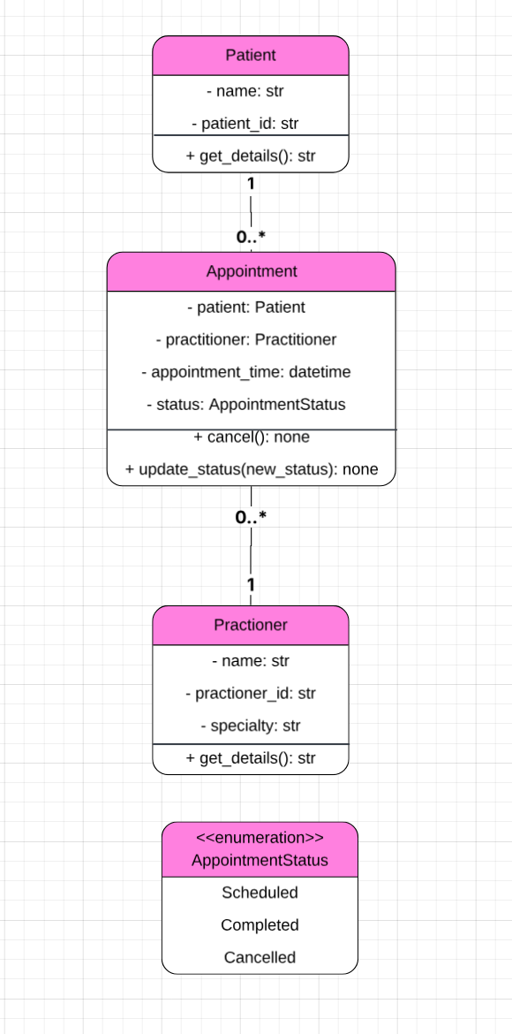
The UML was updated to match the Stage 4 implementation. A specialty attribute was added to the Practitioner class because the implementation requires each practitioner to store a specialty. An AppointmentStatus enum was also added to show the allowed appointment states: SCHEDULED, COMPLETED and CANCELLED.

The Patient–Appointment and Practitioner–Appointment relationships did not change. Each Appointment still has one Patient and one Practitioner, while a Patient or Practitioner can have multiple appointments.

